Andrew Stiles

CSD-430

Prof. Ostrowski

Module 1 Assignment

8/24/2025

I put 3 of the applications/settings into one screen shot. I changed the connector port in the config settings of Tomcat to 80. Had to write a file “setenv.bat” that would allow Tomcat to run on my computer at all. Set my JAVA_HOME to the correct folder.

The Photo shows my JAVA_HOME setting, Tomcat running in the command prompt, Tomcat on my web browser, and eclipse IDE running.

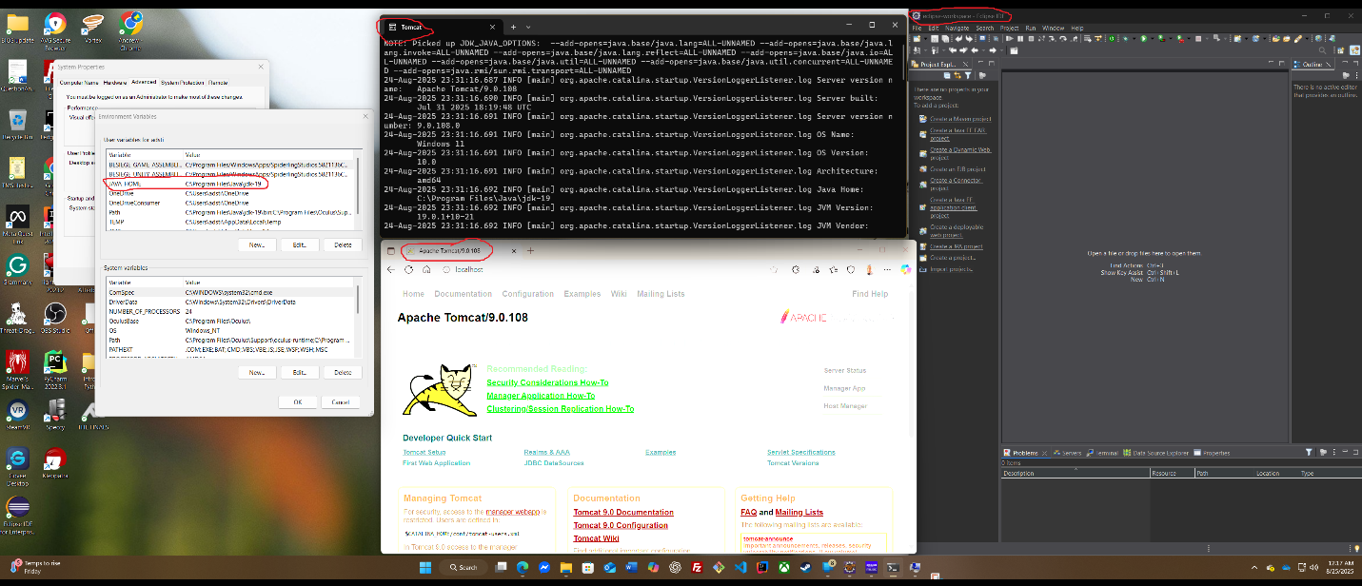

I downloaded the Spring Tools extension, as the full suite program extract just didn’t want to work. I also downloaded it for VS Code and IntelliJ.

Here is the screenshot of my JSP file running in my browser:

